Sum of Integers from 1 to n
AIM:
To write a Prolog program to calculate the sum of integers from 1 to n.
ALGORITHMS:
- Start.
- Read the value of n.
- If n = 0, return sum as 0.
- Otherwise, calculate the sum of n and the sum of integers from 1 to n-1 recursively.
- Display the sum.
- Stop.
CODE:
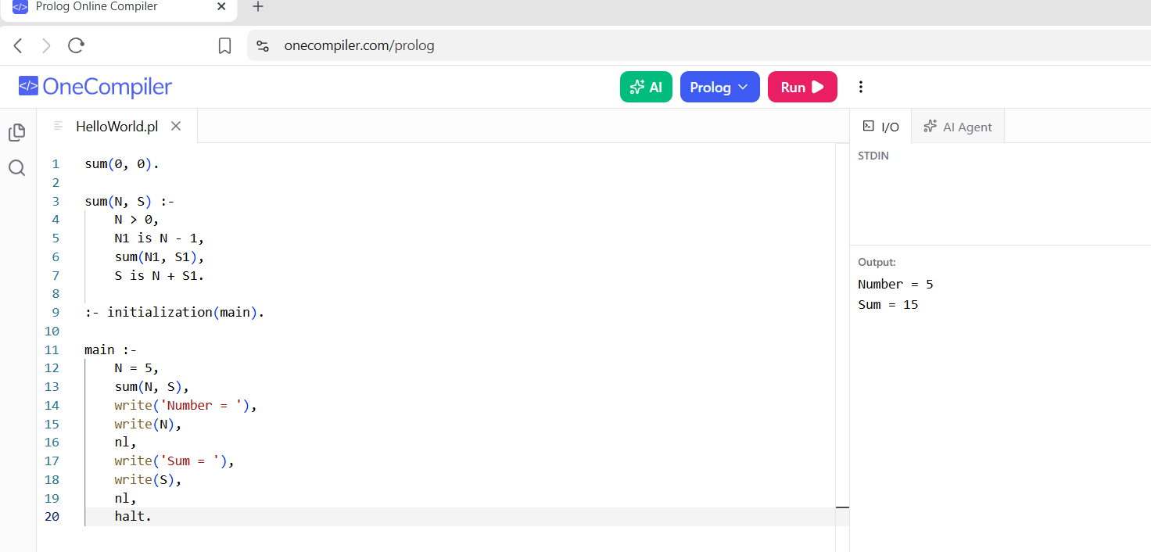

RESULTS:
Sum of Integers from 1 to n: The sum of integers from 1 to the given number
n
n is calculated and displayed.

